**Lesson 1: Functions and Their Representations**

After completing this lesson, you should be able to

* discuss functions and their representations
* discuss piecewise-defined functions
* explain the concept of *symmetry*
* discuss increasing and decreasing functions

**Commentary**

**Topics**

1. [Introduction to Functions and Their Representations](https://content.umuc.edu/file/7bdece95-b196-4233-9313-aa904663b08e/1/MATH140-0909.zip/Modules/M1-Module_1/Lesson_1/S3-Commentary.html#I)
2. [Piecewise-Defined Functions](https://content.umuc.edu/file/7bdece95-b196-4233-9313-aa904663b08e/1/MATH140-0909.zip/Modules/M1-Module_1/Lesson_1/S3-Commentary.html#II)
3. [Symmetry](https://content.umuc.edu/file/7bdece95-b196-4233-9313-aa904663b08e/1/MATH140-0909.zip/Modules/M1-Module_1/Lesson_1/S3-Commentary.html#III)
4. [Increasing and Decreasing Functions](https://content.umuc.edu/file/7bdece95-b196-4233-9313-aa904663b08e/1/MATH140-0909.zip/Modules/M1-Module_1/Lesson_1/S3-Commentary.html#IV)

**1. Introduction to Functions and Their Representations**

**Functions** describe mathematical relationships in which one quantity corresponds to another. These relationships can be described in a variety of ways, such as with a formula, a table, a graph, data, or words. Below are some examples of how functions can be represented.

**Example 1.1.1: Formula Representation of a Function**

According to the National Climatic Data Center (NCDC), the global mean sea level has been rising at an average rate of 0.001 to 0.002 meters (m) per year over the past hundred years—a rate significantly higher than that averaged over the last several thousand years. Projected increases from 1990 to 2100 vary according to the greenhouse gas scenario used and the predictions made of how a variety of frozen and unfrozen water sources will contribute to the rise (NCDC, NCDC Web site).

A global mean projection can be approximated by the equation

*S* = 0.485https://content.umuc.edu/file/7bdece95-b196-4233-9313-aa904663b08e/1/MATH140-0909.zip/Modules/M1-Module_1/Lesson_1/images/sqrt-x.gif + 1800, 1990 ≤ *x* ≤ 2100

where *S* represents the projected global mean sea level (in meters) and *x* represents the number of years after 1990. For each positive number *x*, there is exactly one value of *S* associated with it, and so we say that ***S* is a function of *x***.

**Example 1.1.2: Graph Representation of a Function**

The Draupner wave, a single giant wave measured on New Year's Day in 1995, finally confirmed the existence of rogue waves, abnormally large, spontaneously occurring waves that were previously considered mythical and that are now blamed for a number of heretofore unexplained ship disappearances in the Bermuda Triangle.

Figure 1.1.1 shows a graph of the wave activity at the time and place the Draupner wave occurred. The rogue wave reached nearly 60 feet, appearing from nowhere among waves that were mostly 15 feet or under. The surface deviation *D* in meters *m* can be expressed as a function of time in seconds *s*. For a given value *t* in seconds, the graph provides a corresponding surface deviation *D*, and so we say that ***D* is a function of*****t***.

**Figure 1.1.1  
Draupner Wave Graph**

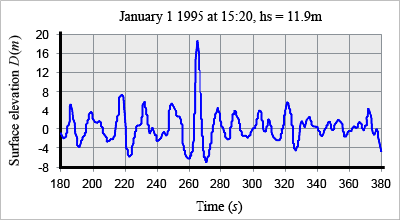

Data source: Wikipedia, 2009, Wikipedia Web site

**Example 1.1.3: Data Representation of a Function**

The amount of time Americans spend per week on work is on the rise. With longer commutes and increased access to communication technologies, Americans are spending more time performing work-related tasks and less time sleeping. The scatter plot shown in figure 1.1.2 describes the median number of hours Americans spend on work as a function of time (years). The median number of hours *H* that Americans spend on work depends on the number of years *t* (with 1970 corresponding to *t* = 0). For each positive number *x*, there is exactly one value of *H* associated with it, and so we say that ***H*is a function of *x***.

**Figure 1.1.2  
Median Number of Hours Americans Spend on Work per Week (1970 –2010)**

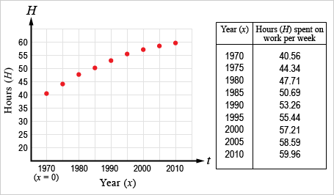

Data source: Harris Interactive Inc., 2008, HarrisInteractive Web site

**Example 1.1.4: Descriptive Representations of a Function**

You fill a balloon with helium and tie it to the back of a chair. The initial time (*t* = 0) corresponds to the moment you began filling the balloon with helium. The volume *V*(*t*) of the balloon depends on the length of time *t* you spent filling it. For each value of time *t*, there is exactly one volume *V* associated with it, and so we say that ***V*is a function of*t***.

In this and the previous examples, for each value of *x* or *t*, there is exactly one value of *S*, *D*, *H*, or *V* associated with it, and so we say that *S* is a function of *x*, *D*is a function of *t*, *H*is a function of *x*, and *V* is a function of *t*.

A **function *f*** is a rule that assigns to each element *x* in a set *A*, called the **domain**, exactly one element *y*, denoted *f*(*x*), in a set *B* called the **range**.

In the functions in this module, *A* and *B* are sets of real numbers, unless otherwise stated. The set *A* is called the*domain* of the function *f*. The function notation *f*(*x*) is used to denote the value of *f* at *x* and is read "*f*of *x*." The *range* of the function *f* is the set of all values of *f*(*x*) as *x* varies over the domain.

A variable representing an arbitrary value in the domain of *f* is called an **independent variable**; a variable representing an arbitrary value in the range of *f* is called a **dependent variable**. In Example 1.1.1 above, *x* is the independent variable and *S* is the dependent variable.

Unless otherwise stated, the domain of a function is assumed to be the largest possible set of real numbers *x* for which the function is well defined. The largest possible set of real numbers *x* is called the **natural domain**. If we consider the volume *V* of a cube as a function of the length of one side *x* of the cube, then the natural domain of *V*(*x*) = *x*3 is *x* > 0, as length is always positive, even when a function has the domain of all real numbers.

Sometimes, it is useful to conceptualize a function as a machine (see figure 1.1.3). Every time we put an *x* into the function machine, the machine generates a result *f*(*x*), and we consider *f*(*x*) the output of the machine.

**Figure 1.1.3  
Depiction of Function as Machine with Input *x* and Output *f*(*x*)**

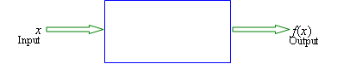

**Note This**

|  |  |
| --- | --- |
| https://content.umuc.edu/file/7bdece95-b196-4233-9313-aa904663b08e/1/MATH140-0909.zip/Modules/M1-Module_1/Lesson_1/images/NoteThisIcon.png | A calculator is one example of a function machine. For example, the squaring key *x*2 will square any real number you input in the calculator; the answer given is the output of the calculator. In some cases, the calculator will give an *approximation* to *x*2; the *x*2 key is therefore not exactly the same as the mathematical function defined by *f*(*x*) = *x*2. |

Figure 1.1.4 shows a schematic diagram of a graphing calculator as a function machine, with *f* as the squaring function.

**Figure 1.1.4  
Depiction of Graphing Calculator as Function Machine**

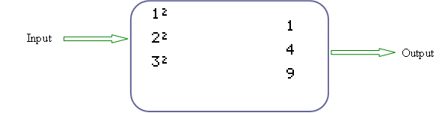

A function can also be visually represented as an arrow diagram (see figure 1.1.5). Each arrow assigns an element of the domain *A* to exactly one element of the set *B*, which contains the range of the function.

**Figure 1.1.5  
Arrow Diagram**

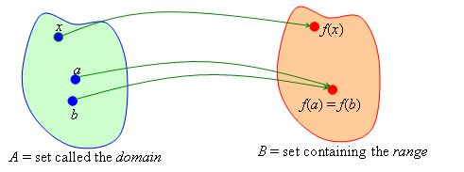

**Note This**

|  |  |
| --- | --- |
| https://content.umuc.edu/file/7bdece95-b196-4233-9313-aa904663b08e/1/MATH140-0909.zip/Modules/M1-Module_1/Lesson_1/images/NoteThisIcon.png | One element in the set *A* cannot be connected to two different elements in the set *B*; however, two different elements in the set *A* can be connected to the same element in the set *B*. |

In figure 1.1.5, the arrow connecting *x* to *f*(*x*) illustrates that *f* assigns *x* to *f*(*x*). The arrows connecting *a* to *f*(*a*) illustrate that *f* assigns *a* to *f*(*a*) and that *f* assigns an element not equal to *a* to *f*(*a*) as well.

Graphing is one of the most common ways of visually representing a function. The graph of a function with the domain *A* is a collection of points whose coordinates consist of the input-output pairs for *f*; this can be written in set notation as

{(*x*, *f*(*x*)) | *x* ∈ *A*}

***Counter*Point:** The equation *y*2 = *x* is not a function, because, for a single element *x* in the domain, say *x* = 4, there are two corresponding elements *y*in the range, namely, *y* = –2 and *y* = 2.

Figure 1.1.6 illustrates this point:

**Figure 1.1.6  
Illustration Showing That *y*2 = *x* is Not a Function**

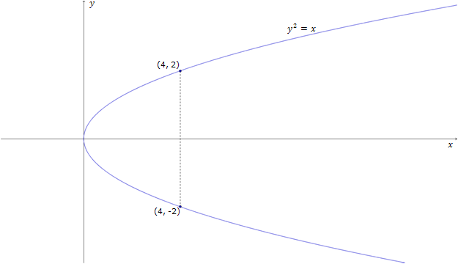

**Exercise 1.1.1: Graph a Representation of a Function I**

The symbol *pH* stands for "potential for hydrogen" and is used to represent the acidic or alkaline level of a system. A pH level of 0 to 6.9 is considered acidic, and a level of 7 to 14 is considered alkaline. According to the American Medical Association (AMA), the pH level of a typical young adult human stomach after the adult has consumed a 12-ounce (oz) carbonated beverage can be described as a function *f* of time *t* (minutes after the beverage was consumed; see figure 1.1.7). (**Note:** The normal pH level of a human stomach is approximately 2.5.)

**Problem**

Use the graph in figure 1.1.7 to do the following:

1. find the values of *f*(0), *f*(10), and *f*(25)
2. find the domain of *f*
3. find the range of *f*
4. use the graph of *f* to describe the short-term impact on your stomach of drinking a 12-oz can of soda

**Figure 1.1.7  
pH Level of Stomach After Drinking Soda**

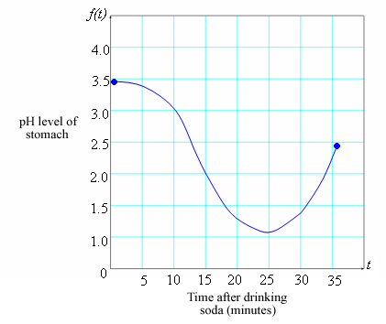

**Solution**

1. We observe from the graph that the point (0, 3.5) lies on the graph of *f*, and so the value of *f* at 0 is *f*(0) = 3.5.

We also observe from the graph that the point (10, 3.0) lies on the graph of *f*, and so the value of *f* at 10 is *f*(10) = 3.0.

At *x* = 25, the graph lies approximately 1.2 units above the *x*-axis, and so we estimate that *f*(25) ≈ 1.2.

1. We observe that *f*(*x*) is defined whenever *x* is between 0 and 35, inclusively, and so the domain is the closed interval [0, 35]. We can write the domain in set notation:

*D* = {*x* | 0 ≤ *x* ≤ 35}

1. We also observe that *f* takes on all *y*-values from 1.2 to 3.5, and so the range is the closed interval [1.2, 3.5]. We can write the range in set notation:

*R* = {*y* | 1.2 ≤ *y* ≤ 3.5}

1. Immediately after you drink a 12-oz soda, the pH level of your stomach is at its highest. The pH reaches its lowest point after approximately twenty-five minutes, and begins to rise back to its normal level approximately thirty-five minutes after the consumption of the beverage.

In the next exercise, you will set up a table of vales (or values) to sketch the graph of a function.

**Exercise 1.1.2: Graph a Representation of a Function II**

**Problem**

Sketch the graph of the function *f*(*x*) = *x*2 and determine its domain and range.

**Solution**

We write the function in equation notation (*y* = *x*2), make a table of *x* and *y* values, and connect them in a graph with a smooth curve.

**Table 1.1.1  
*x* and *y* Values for *f*(*x*) = *x*2**

|  |  |
| --- | --- |
| ***x*** | ***y* = *x*2** |
| –3 | 9 |
| –2 | 4 |
| –1 | 1 |
|  |  |
| 1 | 1 |
| 2 | 4 |
| 3 | 9 |

Here is the graph of the values:

**Figure 1.1.8  
Graph of *f*(*x*) = *x*2**

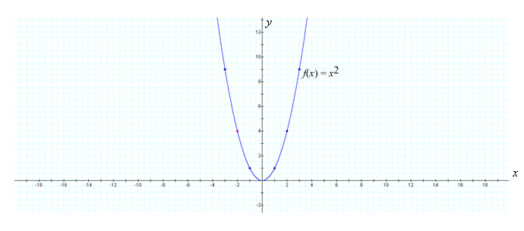

The domain of *f* is all real numbers, *R*. The range of *f* is all real numbers of the form *x*2, and as *x*2 ≥ 0 for all real numbers, the range of *f* is {*y* | *y* ≥ 0} = [0, ∞). The range can also be observed in the graph, where the *y*-values range from 0 to ∞.

**Note This**

|  |  |
| --- | --- |
| https://content.umuc.edu/file/7bdece95-b196-4233-9313-aa904663b08e/1/MATH140-0909.zip/Modules/M1-Module_1/Lesson_1/images/NoteThisIcon.png | In module 3, we will discuss derivatives and how they can help us to understand the shape of a graph. This will give us a better understanding of how the points on a graph are connected. |

In the following exercise, we will sketch the graph of a function, given a verbal description.

**Exercise 1.1.3: Sketch the Graph of a Function**

You are going to develop a rectangular piece of land as a memorial park. The lot has an area of 48 m2. The length of the lot is three times its width. A rectangular path with a width of *x* meters is to be constructed along the inner perimeter of the lot. The land contained within the path will be landscaped. The cost to construct the path is $2 per square meter, and the cost to landscape the inner field is $3 per square meter.

**Problem**

Express the total cost to develop this lot as a function of *x*, the width of the path.

**Figure 1.1.9  
Lot to be Developed**

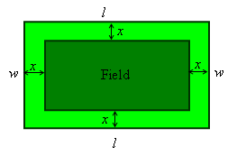

**Solution**

Construct a diagram, letting *l* represent the length of the lot in meters, *w* represent the width of the lot in meters, and *x* represent the width of the path in meters.

The area of the lot, *lw*, is (3*w*)*w* = 3*w*2 = 48, so the width *w* of the lot is 4 meters, and the length *l* is 3*w* = 3(4) = 12 meters.

The length of the field contained by the path is 12 – 2*x*, and the width of the field is 4 – 2*x*, so the area of the field is (12 – 2*x*)(4 – 2*x*) = 4*x*2 – 32*x* + 48. The cost to landscape the field is (cost per square meter) times (area of the field), so the cost to landscape the field is 3(4*x*2 – 32*x* + 48).

The area of the path is the area of the lot of land minus the area of the field, so the area of the path is 48 – (4*x*2 – 32*x* + 48) = –4*x*2 – 32*x*. The cost to construct the path is 2(–4*x*2 + 32*x*).

The total cost to develop the land is therefore

3(4*x*2 – 32*x* + 48) + 2(–4*x*2 + 32*x*) = 4*x*2 – 32*x* + 144

The total cost *C*, expressed as a function of *x*, is

C(*x*) = 4*x*2 – 32*x* + 144, *x* > 0

Why must *x* be greater than zero? Understanding the domain of a function is an important part of understanding its context. It can be very useful to find the domain of a function early on. In the exercise below, we will find the domain of selected functions.

**Exercise 1.1.4: Find the Domain of Functions**

**Problem**

Find the domain of each function.

1. *f*(*x*) = https://content.umuc.edu/file/7bdece95-b196-4233-9313-aa904663b08e/1/MATH140-0909.zip/Modules/M1-Module_1/Lesson_1/images/lesson1-ex1-1-4-prob-a.gif
2. *g*(*x*) = https://content.umuc.edu/file/7bdece95-b196-4233-9313-aa904663b08e/1/MATH140-0909.zip/Modules/M1-Module_1/Lesson_1/images/lesson1-ex1-1-4-prob-b.gif
3. *h*(*x*) =https://content.umuc.edu/file/7bdece95-b196-4233-9313-aa904663b08e/1/MATH140-0909.zip/Modules/M1-Module_1/Lesson_1/images/lesson1-ex1-1-4-prob-c.gif
4. *s*(*t*) = *vt* – 9.8*t*2, where *v* is fixed initial velocity, and *t* is time

**Solution**

1. https://content.umuc.edu/file/7bdece95-b196-4233-9313-aa904663b08e/1/MATH140-0909.zip/Modules/M1-Module_1/Lesson_1/images/lesson1-ex1-1-4-soltn-a.gif is not defined when the denominator is zero, and so *f*(*x*) is not defined when *x* = –2 or *x* = 3. Therefore, the domain of *f* is

{*x* | *x* ≠ –2 or *x* ≠ 3}

which can be written in interval notation:

(–∞, –2) ∪ (–2, 3) ∪ (3, ∞)

1. *g*(*x*) = https://content.umuc.edu/file/7bdece95-b196-4233-9313-aa904663b08e/1/MATH140-0909.zip/Modules/M1-Module_1/Lesson_1/images/lesson1-ex1-1-4-prob-b.gif is not defined when the value under the radical is negative, so *g*(*x*) is defined only for those values of *x* that satisfy 2*x* – 6 ≥ 0. This is equivalent to *x* ≥ 3. Therefore, the domain of *g* is

{*x* | *x* ≥ 3}

which can be written in interval notation:

[3, ∞)

1. *h*(*x*) = https://content.umuc.edu/file/7bdece95-b196-4233-9313-aa904663b08e/1/MATH140-0909.zip/Modules/M1-Module_1/Lesson_1/images/lesson1-ex1-1-4-prob-c.gif is not defined when the value under the radical is negative or when the denominator is zero, so *g*(*x*) is defined only for those values of *x* that satisfy 2*x* – 6 > 0. This is equivalent to *x* > 3. Therefore, the domain of *g* is

{*x* | *x* > 3}

which can be written in interval notation:

(3, ∞)

1. The equation *s*(*t*) = *vt* – 9.8*t*2 is the polynomial that describes the distance a projectile travels. The domain of any polynomial is all real numbers. In this particular case, because time is the domain variable (and time cannot be negative), we limit the domain to all nonnegative real numbers. That is,

*D* = {*t* | *t* ≥ 0}, or in interval notation, [0, ∞)

Each of the equations in this exercise is a function, and the curve of each in the plane represents the graph of a function. Not all equations are graphs of functions. How can we determine whether or not a curve is the graph of a function? The *vertical line test* can help us answer this question.

**Vertical Line Test**

A curve in the plane is the graph of a function if and only if there does not exist a vertical line that intersects the curve at more than one point.

Why is the vertical line test valid? In figure 1.1.10, any vertical line *x* = *a* will intersect the curve at only one point, say, (*a*, *b*). So, for any *x* value, the curve will have only one corresponding *f*(*x*) value, satisfying the requirement of a curve to be the graph of a function.

**Figure 1.1.10  
Curve That is the Graph of a Function I**

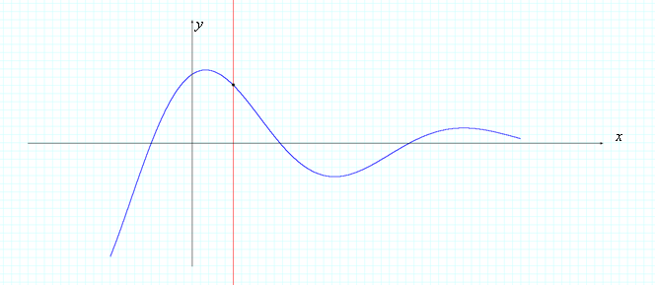

However, if there is a line *x* = *a* that intersects the curve at more than one point, as is the case for the circle in figure 1.1.11, the curve cannot be the graph of a function, as a function cannot assign one value in the domain to two different values in the range.

**Figure 1.1.11  
Curve That is Not the Graph of a Function**

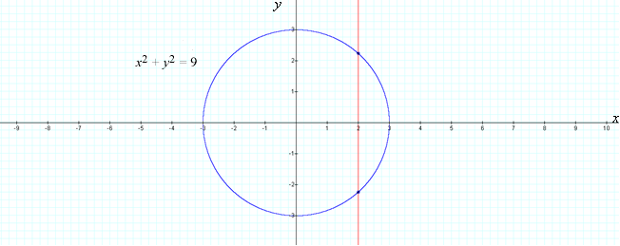

This circle is *not* the graph of a function, as it does not pass the vertical line test.

The circle can be decomposed into graphs of two functions of *x*, the upper half of the circle defined by the function *f*(*x*) = https://content.umuc.edu/file/7bdece95-b196-4233-9313-aa904663b08e/1/MATH140-0909.zip/Modules/M1-Module_1/Lesson_1/images/lesson1-ex1-1-11-equtn.gif, and the lower half of the circle defined by the function *g*(*x*) = –https://content.umuc.edu/file/7bdece95-b196-4233-9313-aa904663b08e/1/MATH140-0909.zip/Modules/M1-Module_1/Lesson_1/images/lesson1-ex1-1-11-equtn.gif (see figures 1.1.12a and 1.1.12b).

In figure 1.1.12a, the upper half of the circle is the graph of a function, as it passes the vertical line test.

**Figure 1.1.12a  
Curve That is the Graph of a Function II**

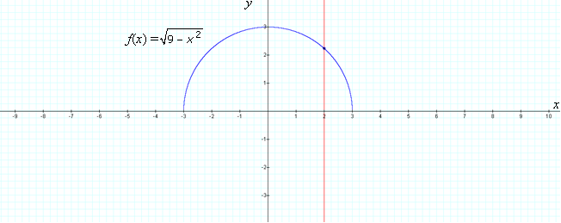

In figure 1.1.12b, the lower half of the circle is the graph of a function, as it passes the vertical line test.

**Figure 1.1.12b  
Curve That is the Graph of a Function III**

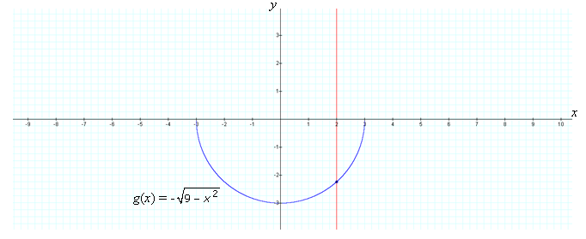

**2. Piecewise-Defined Functions**

A **piecewise-defined function** is a function defined by two or more formulas, or *pieces of the function*, each with a specified domain. The examples in the following exercises can be defined by piecewise functions.

**Exercise 1.1.5: Write a Piecewise Function**

The **absolute value function** is another example of a piecewise-defined function. Recall that the absolute value of a real number *a* is the distance from *a* to 0 on the real number line. For example, |5| = 5, |–5| = 5, |0| = 0; |π – 4| = 4 – π.

For any real number *r*,

|*r*| = *r* if *r* ≥ 0

|*r*| = –*r* if *r* < 0

**Note This**

|  |  |
| --- | --- |
| https://content.umuc.edu/file/7bdece95-b196-4233-9313-aa904663b08e/1/MATH140-0909.zip/Modules/M1-Module_1/Lesson_1/images/NoteThisIcon.png | If *r* is negative, then –*r* is positive. For example, if *r* = –2, then |–*r*| = –(–2) = 2. |

**Exercise 1.1.6: Sketch the Graph of an Absolute Value Function**

**Problem**

Sketch a graph of the absolute value function *f*(*x*) = |*x*|.

**Solution**

We apply the same principle that we discussed regarding the absolute value of real numbers to write the absolute value function as a piecewise-defined function:

|*x*|https://content.umuc.edu/file/7bdece95-b196-4233-9313-aa904663b08e/1/MATH140-0909.zip/Modules/M1-Module_1/Lesson_1/images/lesson1-ex1-1-6-soltn.gif

We apply the technique described in the example below to sketch the graph of *y* = *x* and *y* = –*x* on the same coordinate system.

**Figure 1.1.14  
Graph of *y* = |*x*| and *y* = –*x***

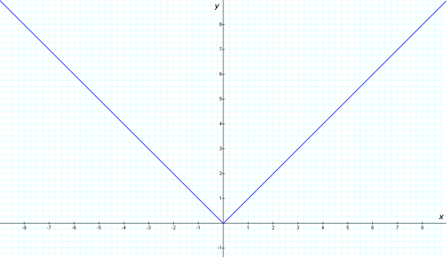

**Example 1.1.5: Greatest Integer Function**

The **greatest integer function**, or *integer floor function*, is defined as https://content.umuc.edu/file/7bdece95-b196-4233-9313-aa904663b08e/1/MATH140-0909.zip/Modules/M1-Module_1/Lesson_1/images/openbracket-x.gif= the largest integer less than or equal to *x*. For example, https://content.umuc.edu/file/7bdece95-b196-4233-9313-aa904663b08e/1/MATH140-0909.zip/Modules/M1-Module_1/Lesson_1/images/openbracket-2.gif = 2, https://content.umuc.edu/file/7bdece95-b196-4233-9313-aa904663b08e/1/MATH140-0909.zip/Modules/M1-Module_1/Lesson_1/images/openbracket-266.gif = 2, https://content.umuc.edu/file/7bdece95-b196-4233-9313-aa904663b08e/1/MATH140-0909.zip/Modules/M1-Module_1/Lesson_1/images/openbracket--3-5.gif = –4, and https://content.umuc.edu/file/7bdece95-b196-4233-9313-aa904663b08e/1/MATH140-0909.zip/Modules/M1-Module_1/Lesson_1/images/openbracket-pi.gif = 3. Figure 1.1.15 shows the graph of *f*(*x*) = https://content.umuc.edu/file/7bdece95-b196-4233-9313-aa904663b08e/1/MATH140-0909.zip/Modules/M1-Module_1/Lesson_1/images/openbracket-x.gif.

**Figure 1.1.15  
Greatest Integer Function**

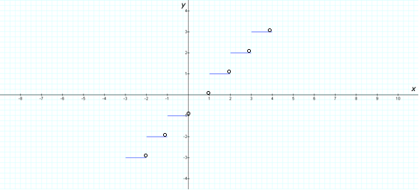

**Note This**

|  |  |
| --- | --- |
| https://content.umuc.edu/file/7bdece95-b196-4233-9313-aa904663b08e/1/MATH140-0909.zip/Modules/M1-Module_1/Lesson_1/images/NoteThisIcon.png | An open circle on a graph indicates that the point is *not* included in the graph. A closed circle on a graph indicates that the point*is*included in the graph. |

**Example 1.1.6: Least Integer Function**

The **least integer function**, or *integer ceiling function*, is defined as https://content.umuc.edu/file/7bdece95-b196-4233-9313-aa904663b08e/1/MATH140-0909.zip/Modules/M1-Module_1/Lesson_1/images/ceilingfunc-x.gif = the smallest integer greater than or equal to *x*. For example, https://content.umuc.edu/file/7bdece95-b196-4233-9313-aa904663b08e/1/MATH140-0909.zip/Modules/M1-Module_1/Lesson_1/images/ceilingfunc-7.gif = 7, https://content.umuc.edu/file/7bdece95-b196-4233-9313-aa904663b08e/1/MATH140-0909.zip/Modules/M1-Module_1/Lesson_1/images/ceilingfunc-2-1.gif = 3, https://content.umuc.edu/file/7bdece95-b196-4233-9313-aa904663b08e/1/MATH140-0909.zip/Modules/M1-Module_1/Lesson_1/images/ceilingfunc--3-6.gif= –3, and https://content.umuc.edu/file/7bdece95-b196-4233-9313-aa904663b08e/1/MATH140-0909.zip/Modules/M1-Module_1/Lesson_1/images/ceilingfunc-pi.gif = 4. Figure 1.1.16 shows the graph of *f*(*x*) = https://content.umuc.edu/file/7bdece95-b196-4233-9313-aa904663b08e/1/MATH140-0909.zip/Modules/M1-Module_1/Lesson_1/images/ceilingfunc-x.gif. Functions like the ones in this and the previous example are often referred to as *step functions*because they jump from one value of *f* to another (and look similar to the steps of a staircase when graphed).

**Figure 1.1.16  
Least Integer Function**

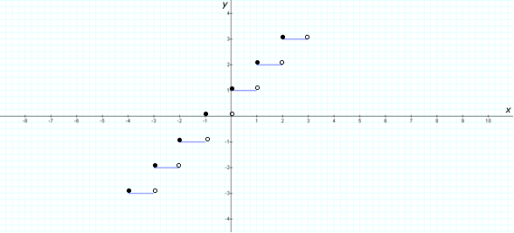

**Note This**

|  |  |
| --- | --- |
| https://content.umuc.edu/file/7bdece95-b196-4233-9313-aa904663b08e/1/MATH140-0909.zip/Modules/M1-Module_1/Lesson_1/images/NoteThisIcon.png | The notation [*x*] has also been used to indicate the greatest integer function, or the integer floor function. The use of bracket notation stems from the work of Carl Friedrich Gauss on number theory, conducted in the early 1800s. To read more about Gauss, visit this[Wikipedia page](http://en.wikipedia.org/wiki/Carl_Friedrich_Gauss). |

**Exercise 1.1.7: Find a Formula**

**Problem**

Find a formula for *f*(*x*), given in figure 1.1.17:

**Figure 1.1.17  
Graph of *f*(*x*)**

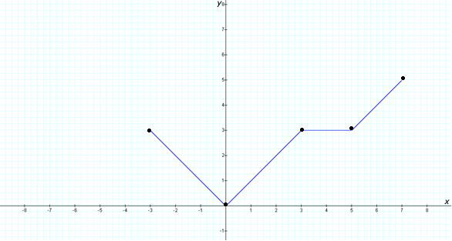

**Solution**

The line that passes through the points (–3, 3) and (0, 0) has slope *m* = –1 and *y*-intercept *b* = 0; therefore, the equation of the line is *y* = –*x*, and so

*f*(*x*) = –*x* if –3 ≤ *x* ≤ 0

The line passing through the points (0, 0) and (3, 3) has slope *m* = 1 and *y*-intercept *b* = 0; therefore, the equation of the line is *y* = *x*, giving us

*f*(*x*) = *x* if 0 < *x* ≤ 3

The horizontal line passing through the points (3, 3) and (5, 3) is *y* = 3, giving us

*f*(*x*) = 3 if 3 < *x* ≤ 5

The line passing through the points (5, 3) and (7, 5) has slope *m* = 1. We use the point-slope form to determine that the equation of the line is *y* = *x* – 2, giving us

*f*(*x*) = *x* – 2 if 5 < *x* ≤ 7

Putting all this together gives us the following piecewise definition for *f*(*x*):

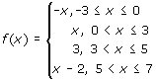

**3. Symmetry**

Graphs of functions can have symmetry properties, including symmetry with respect to the *y*-axis and symmetry with respect to the origin. We define two types of symmetry properties that functions can have:

A function is said to be an **even function** if and only if *f*(–*x*) = *f*(*x*) for every *x* in the domain of *f*. For example, *f*(*x*) = *x*2 is an even function, as *f*(–*x*) = (–*x*)2 = *x*2 = *f*(*x*).

A function is said to be an **odd function**if and only if *f*(–*x*) = –*f*(*x*) for every *x* in the domain of *f*. For example, *f*(*x*) = *x*3 is an odd function, as *f*(–*x*) = (–*x*)3 = –*x*3 = –*f*(*x*).

The graph of an even function is symmetric with respect to the *y*-axis (see figure 1.1.18).

**Figure 1.1.18  
Graph of an Even Function**

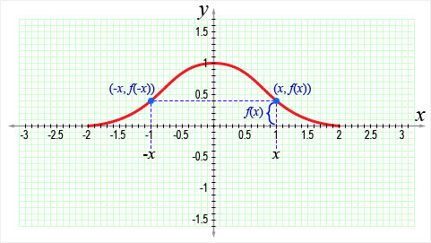

**Note This**

|  |  |
| --- | --- |
| https://content.umuc.edu/file/7bdece95-b196-4233-9313-aa904663b08e/1/MATH140-0909.zip/Modules/M1-Module_1/Lesson_1/images/NoteThisIcon.png | If we know the graph of an even function for *x* ≥ 0, we can obtain the entire graph by reflecting the known portion of the graph through the *y*-axis. The graph of an odd function is symmetric with respect to the origin (see figure 1.1.19). That is, if (*x*, *y*) lies on the graph of *f*(*x*), then (–*x*, –*y*) also lies on the graph of *f*(*x*). |

**Figure 1.1.19  
Graph of an Odd Function**

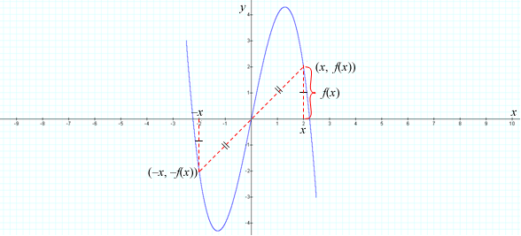

**Note This**

|  |  |
| --- | --- |
| https://content.umuc.edu/file/7bdece95-b196-4233-9313-aa904663b08e/1/MATH140-0909.zip/Modules/M1-Module_1/Lesson_1/images/NoteThisIcon.png | If we know the graph of an odd function for *x* ≥ 0, then we can obtain the entire graph by rotating the known portion 180 degrees (°) about the origin. We can create an animation of the graph rotating 180° showing that the point (–*x*, –*f*(*x*)) rotates to the point (*x*, *f*(*x*)), and that the point (*x*, *f*(*x*)) rotates to the point (–*x*, –*f*(*x*)). |

**Exercise 1.1.8: Determine Whether Functions are Odd or Even**

**Problem**

Determine whether each of the following functions is even, odd, or neither.

1. *f*(*x*) = 3*x*4 – 5*x*2
2. *g*(*x*) = *x*9 – *x*3 – *x*
3. *h*(*x*) = *x*3 + *x*2

**Solution**

1. Consider *f*(–*x*) = 3(–*x*)4 – 5(–*x*)2

= 3*x*4 – 5*x*2

= *f*(*x*)

Therefore, *f* is an even function (see figure 1.1.20).

**Figure 1.1.20  
Even Function *f*(*x*) = 3*x*4 – 5*x*2**

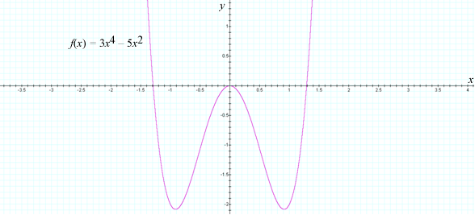

1. Consider *g*(–*x*) = (–*x*)9 – (–*x*)3 – (–*x*)

= (–1)9*x*9 – (–1)3*x*3 + *x*

= –*x*9 + *x*3 + *x*

= –(*x*9 – *x*3 – *x*)

= –*g*(*x*)

Therefore, *g* is an odd function (see figure 1.1.21).

**Figure 1.1.21  
Odd Function *g*(*x*) = *x*9 – *x*3 – *x***

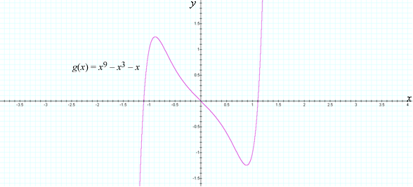

1. Consider *h*(–*x*) = (–*x*)3 + (–*x*)2

= (–1)3*x*3 + (–1)2*x*2

= –*x*3 + *x*2

As *h*(–*x*) is neither *h*(*x*) nor *h*(–*x*), we can say that *h* is neither even nor odd (see figure 1.1.22).

**Figure 1.1.22  
*g*(*x*) = *x*3 + *x*2, Neither Even Nor Odd**

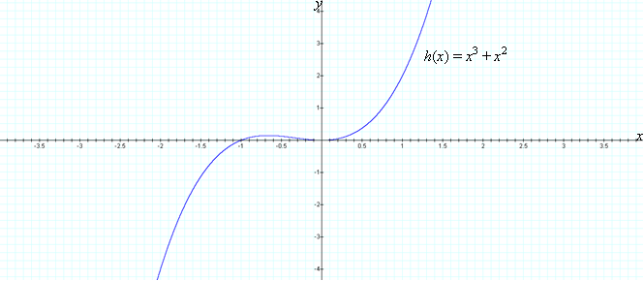

**4. Increasing and Decreasing Functions**

Observe that the graph in figure 1.1.23 rises from *A* to *B* and falls from *B* to *C*, then rises again from *C* to *D*. When the graph of a function rises from left to right, we say that the function is *increasing*, and when the function falls from left to right, we say that the function is *decreasing*. Stated more formally, the function in figure 1.1.23 is increasing on the closed interval [*a*, *b*], decreasing on the closed interval [*b*, *c*], andincreasing on the closed interval [*c*, *d*]. In general, we have the following definition for increasing and decreasing functions:

A function *f* is said to be **increasing** on an interval *I* if and only if

*f*(*x*1) < *f*(*x*2) whenever *x*1 < *x*2

A function *f* is said to be **decreasing** on an interval *I* if and only if

*f*(*x*1) > *f*(*x*2) whenever *x*1 < *x*2

**Figure 1.1.23  
Increasing and Decreasing Functions**

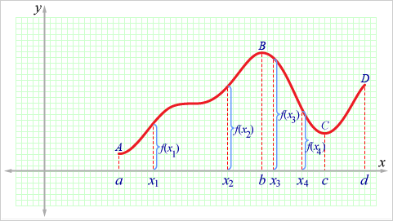

**Note This**

|  |  |
| --- | --- |
| https://content.umuc.edu/file/7bdece95-b196-4233-9313-aa904663b08e/1/MATH140-0909.zip/Modules/M1-Module_1/Lesson_1/images/NoteThisIcon.png | The definition for increasing and decreasing functions must be satisfied for every pair of points *x*1 and *x*2 in the interval *I* with *x*1 < *x*2. |

In figure 1.1.24, the function *f*(*x*) = *x*2 decreases on the interval (–∞, 0] and increases on the interval [0, ∞).

**Figure 1.1.24  
Decreasing and Increasing Function**

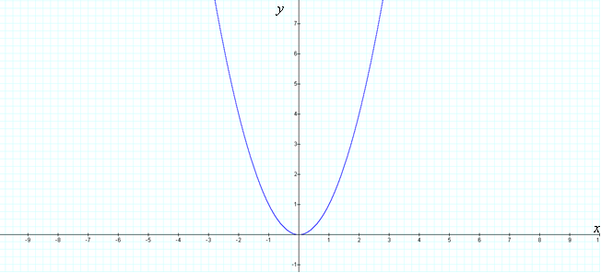

**References**

Draupner wave. (2009). Retrieved March 13, 2009, from Wikipedia: http://en.wikipedia.org/wiki/Draupner_wave

Leisure time plummets 20% in 2008—hits new low. (2008, December 4). Harris Interactive Inc. Web site. Retrieved March 13, 2009, from http://www.harrisinteractive.com/harris_poll/index.asp?PID=980

National Climatic Data Center (NCDC). (n.d.). Sea level data. Retrieved March 13, 2009, from http://www.ncdc.noaa.gov/oa/ncdc.html

[*Return to top of page*](https://content.umuc.edu/file/7bdece95-b196-4233-9313-aa904663b08e/1/MATH140-0909.zip/Modules/M1-Module_1/Lesson_1/S3-Commentary.html#pagetop)

[**Report broken links or any other problems on this page.**](http://help.umuc.edu/)  
  
[**Copyright © by University of Maryland University College.**](https://content.umuc.edu/file/7bdece95-b196-4233-9313-aa904663b08e/1/MATH140-0909.zip/common/copyright.html)